


PROGRAM SCHEDULE
*Held at Kemp Field*
May 9, 2026, Saturday: 9:45 -10:45am
May 16, 2026, Saturday: 9:45-10:45am
May 20, 2026, Wednesday: 6:00-7:00pm
May 23, 2026, Saturday: 9:45-10:45am
May 27, 2026, Wednesday: 6:00-7:00pm
May 30, 2026, Saturday: 9:45 -10:45am

*PLEASE wear your jersey on the LAST DAY for photos*

1st Grade PREP LACROSSE
Farmington Recreation Department

Lacrosse is a growing sport, and we want to introduce it to you! This 6-day program will help your child learn introductory skills in a fun creative way with Director Cam McAllister, and other volunteers.
REGISTER ONLINE
farmingtonme.myrec.com
Registration open until April 24, 2026
Registration Fees:
Includes Jersey Fee
Farmington Residents: $35.00
Non-Residents: $45.00


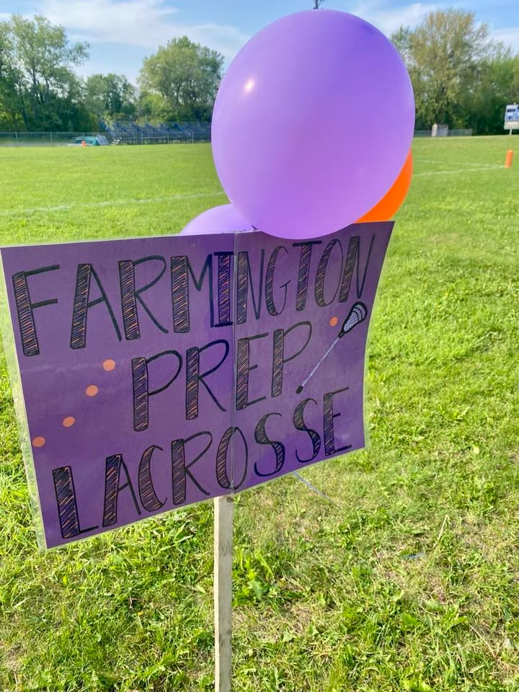
Director Cameron McAllister

Mr. McAllister is a 3rd grade teacher at Cascade Brook School and is dedicated to the development of our youth athletes. He played lacrosse for the University of Maine at Farmington, where he was a two-year team captain. He now serves as the Head Coach of Mt. Blue Middle School Boys Lacrosse and has instructed youth lacrosse through the Recreation Department since its beginnings. In addition, Cam has directed the Fall Youth Soccer League and led both the D1 and D2 Basketball Leagues. He is committed to helping young athletes build confidence, develop skills, and foster a lifelong love of sports.

