In the event of inclement weather please check our Facebook page (www.facebook.com/farmingtonrec) for notice of any cancellations. Announcements should be posted one hour before event.
For more information about this program, call 778-3464 Monday through Friday 9:00am to 5:00pm.
(The Community Center is closed from 12:30pm-1:30pm each day for lunch/errands)

Register online at Farmingtonme.myrec.com
Registration ends September 10, 2026
Resident Fee- $40.00 Includes Jersey
Non-Resident- $50.00 Includes Jersey

The focus of these two programs is to teach fundamentals, introduce skills, educate them in the rules and basic concepts of soccer. Having fun is the primary goal of the program so good sportsmanship is expected of all players and spectators; respect and support should be displayed for every player, director, and volunteer.
Important Information:
- Register online at Farmingtonme.myrec.com by September 10th
- In the interest of fairness, any child that participates in another soccer program during the same time frame will not be allowed to register for the FYSL
- If insurance coverage is desired, it is the responsibility of the participant
- For any families who may need a fee subsidy, please contact the Recreation Department at (207) 778-3464
- For weather cancelations, please check www.facebook.com/farmingtonrec. Announcements will be posted at least one hour before the event start time.
- For more information, call 207-778-3464 or email farmingtonrec@farmington-maine.org



PREP SOCCER CLUB
(First Grade)
First grade will be prepping for our soccer league the following year. Athletes will be split into small groups to refine skills and understand rules of the game. They will participate in exciting drills, and scrimmage often to make sure that the players are ready to advance to the next level and join their FYSL team next year, all while fostering a lifelong love for the sport!
Starts Saturday, September 12, 2026
Ends Saturday, October 10, 2026

All sessions are SATURDAYS 9:45-10:45am

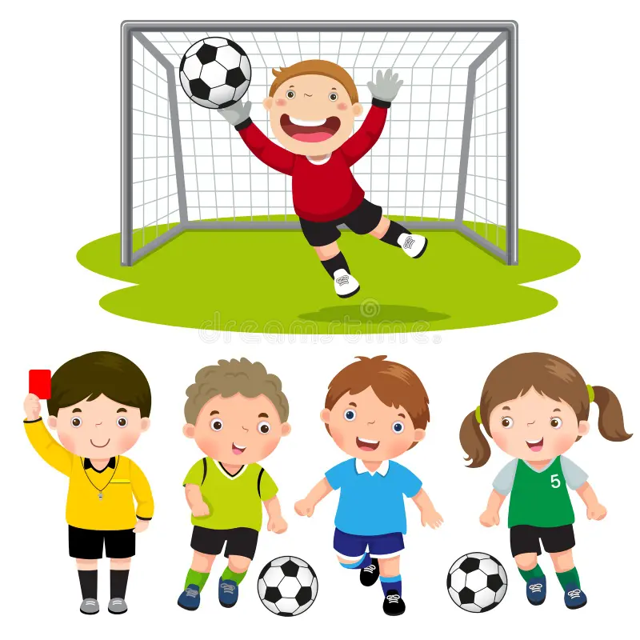
Big Kicks
(Kindergarten)
Kindergarten will be working in small groups to learn how to kick, pass, shoot, trap, throw, and score a goal. With soccer there is a lot to learn, and we enjoy teaching it in a fun way to set you up for years to come and start building their love for the game.

Starts Saturday, September 12, 2026
Ends Saturday, October 10, 2026

All sessions are SATURDAYS 8:30-9:30am


