**Farmington Recreation Department**

**AFTER SCHOOL HOURS**

Monday, Wednesday, & Friday 2:15pm-5:15pm

6th through 12th Grade

Beginning November 13, 2024

**OPEN GYM:**



Basketball

Football

Soccer

Frisbee

Floor Hockey

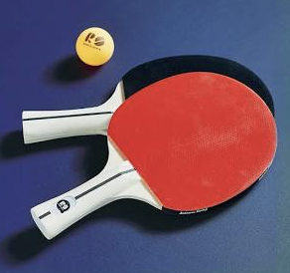 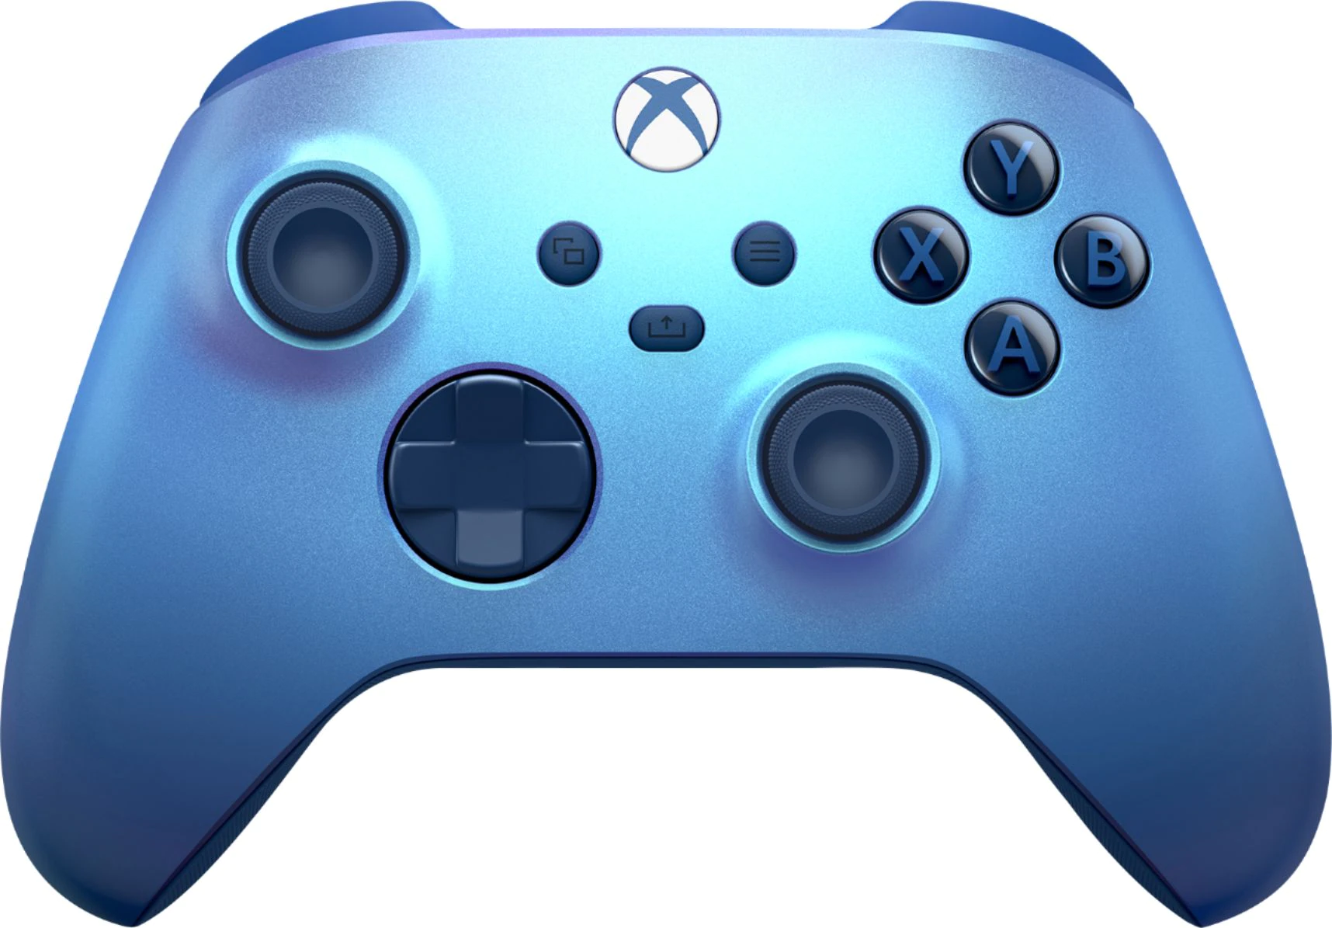 

**DOWNSTAIRS:**

Video Games

Air Hockey

Ping Pong

Foosball

Middle Schoolers walk down from the Middle School.

High Schoolers ride Bus 8 and 45 First Wave and be dropped off at the Recreation Department.

Pick up is between 5:00PM and 5:15PM

**Questions?** Call: 207-778-3464

**REGISTER ONLINE- farmingtonme.myrec.com**

**This is not a Mt. Blue RSU 9 sponsored activity; however, its materials are being distributed through the public schools as a community service. All costs associated with this program flyer are paid for by the Farmington Recreation Department.**