
YOUTH

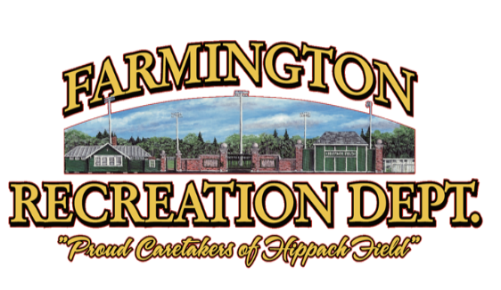
Skills, Drills, & Gear

D1- Monday, April 6, 5:30-7:00PM Saturday, April 11, 11:30AM-1:00PM

D2- Wednesday, April 8, 5:30PM-7:00PM
Saturday, April 11, 9:30AM-11:00AM

Our league helps children develop their skills, get a better understanding of the game through structured practices, and gain experience in competitive play. We welcome players of all skill levels!

Registration Period:
Open Until April 3rd, 2026
REGISTER ONLINE
farmingtonme.myrec.com
Director Cameron McAllister
Mr. McAllister is a 3rd grade teacher at Cascade Brook School and is dedicated to the development of our youth athletes. He played lacrosse for the University of Maine at Farmington, where he was a two-year team captain. He now serves as the Head Coach of Mt. Blue Middle School Boys Lacrosse and has instructed youth lacrosse through the Recreation Department since its beginnings. In addition, Cam has directed the Fall Youth Soccer League and led both the D1 and D2 Basketball Leagues. He is committed to helping young athletes build confidence, develop skills, and foster a lifelong love of sports.
This coed league uses modified boys’ rules. All players must wear a mouthguard for practices and games. We have a limited supply of helmets, sticks, elbow pads, and gloves. Players are encouraged to get their own gear.

*D2 players are required to have chest protection this season. We strongly recommend families purchase a properly fitted chest protector for their child to ensure the best fit, comfort, and safety. If you have questions, please reach out to Michelle or Jen at (207)778-3464.
For more information: Call (207) 778-3464 or visit www.facebook.com/farmingtonrec

We will be at the Community Center until field conditions allow for outdoor practices at Kemp Field. TBA!

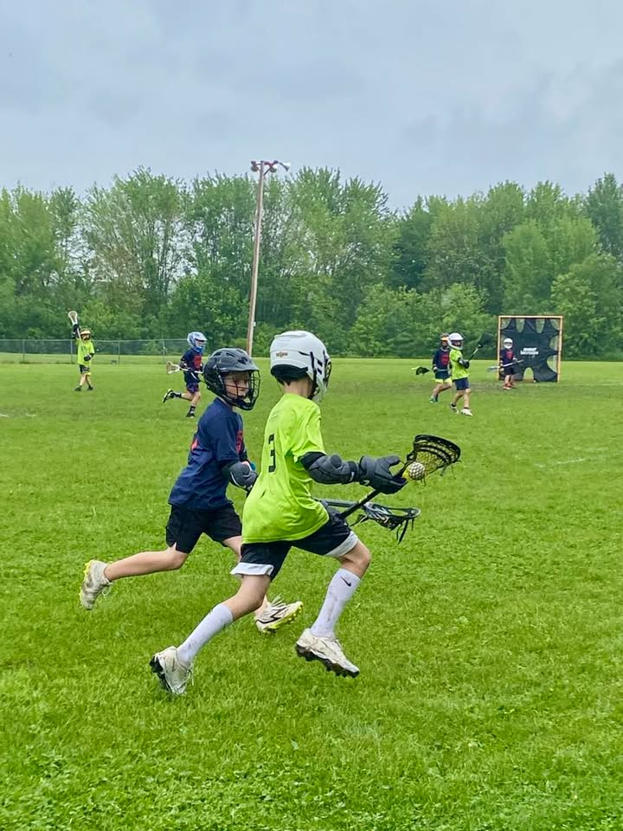
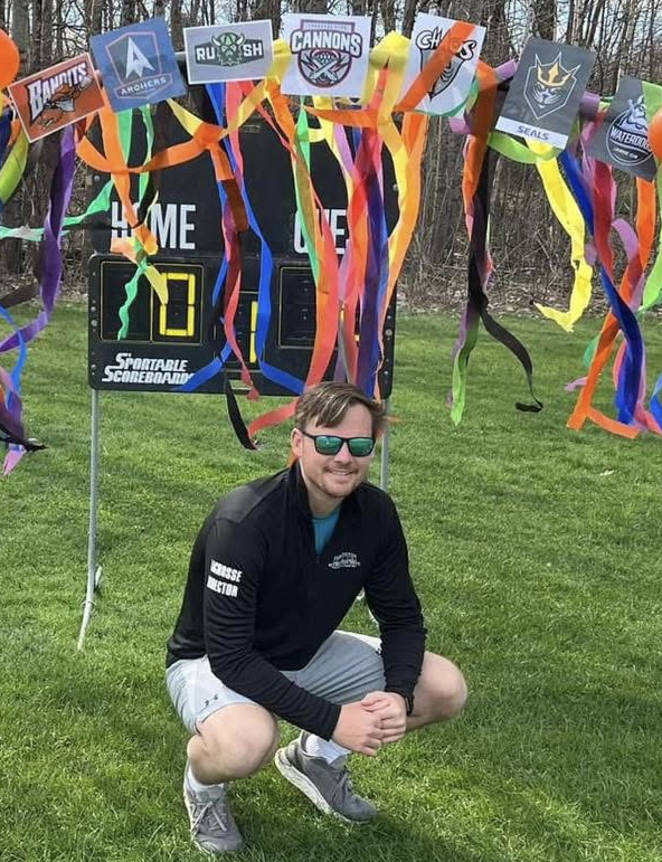
Registration Fees:
Farmington Residents: $50.00
Non-Residents: $65.00
(Jersey Fee Included)

Division Two: 4th– 6th Grade
Practices Tuesdays & Thursdays 5:30-7:00PM
First Practice April 14, 2026
Finale Day June 6, 2026
Games Saturdays between 9:15 & 11:30AM.

Division One: 2nd– 3rd Grade
Practices Wednesdays 5:30-7:00PM
First Practice April 15, 2026
Finale Day June 6, 2026
Games Saturdays between 12:00 & 2:00PM

LEAGUE

