

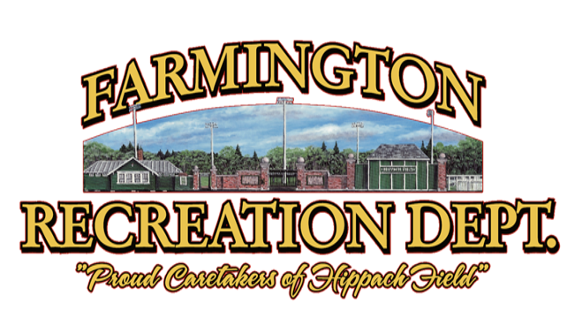



We are excited to begin our first year of winter cheer. Our staff are excited to guide your children through the sport of cheer as we cheer for our Jr. Pro D2 Basketball teams!

The program is open to all children 3rd through 8th grade and is meant to introduce children to cheering! Focus will be on having fun while learning the fundamentals of cheer and also developing a love for the sport.

Practices will be held on Wednesday evenings from 5:30pm-7:00pm at the Cascade Brook School gymnasium (162 Learning Lane, Farmington, Maine.)

Games will typically be Saturday mornings and a schedule will be handed out as soon as we have all the dates!
For more information, contact us at 207-778-3464, visit farmingtonme.myrec.com, or www.facbook.com/farmingtonrec

The program will include a t-shirt and bow. A list of other apparel will be recommended while cheering.

February 4th

January 7th, 14th, 21st, and 28th

Practice Dates: December 3rd, 10th, and 17th

REGISTER online at farmingtonme.myrec.com
REGISTRATIONS end November 28th, 2025
$35.00 Residents
$45.00 Non-Residents
FEES INCLUDE T-SHIRT & BOW
Youth Cheer
3rd through 8th Grade

