
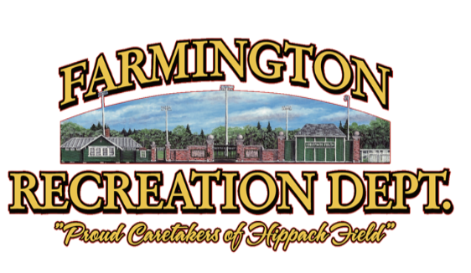
Farmington YOUTH INDOOR SOCCER League
Registrations are open ONLINE at farmingtonme.myrec.com for our Indoor Soccer League for 3rd through 8th Grade. This program will take place at the Farmington Community Center, located at 127 Middle Street.
Registrations close Wednesday, February 25th, 2026.


REGISTRATION
Sign up through Wednesday, February 25th
Online: farmingtonme.myrec.com
In Town Residents - $45.00
Out of Town Residents - $60.00
(JERSEY FEE IS INCLUDED)

Indoor Soccer will take place on Mondays, Thursdays, and Saturdays starting March 2nd through March 29, 2025. This league is geared towards children who have had some soccer experience whereas it is indoors and at a higher speed of play. This league consists of all games and no practices. It is a fun way to stay active during Maine’s muddy season and get lots of touches on the ball.
Each team will play regular season games, and then have a playoff schedule on the last Saturday.
Division One: Grade 3-5 Thursdays starting at 5:30pm and Saturday mornings.
(Exact schedule will be handed out on the first day, March 5, 2026, and posted online.)

Division Two: Grades 6-8 Mondays starting at 5:30pm and Saturday mid-morning/afternoon.
(Exact schedule will be handed out on the first day, March 2, 2026, and posted online.)

Schedules will be given out at the first game. All rosters will be posted on our Facebook page (www.facebook.com/farmingtonrec)
Please check our Facebook page for cancellations and postponements!

For more information call Griffin Conlogue 207-779-4853 or the Rec Dept. at 778-3464
This is not an RSU 9 sponsored activity, but its information is being distributed through the public schools as a community service. All costs associated with
this flyer are paid for by the Farmington Recreation Department.

DIRECTOR: Griffin Conlogue is the Mt. Blue High School girls’ varsity soccer coach and the Western Maine United soccer vice president. Griffin was a player in the Farmington Rec Indoor Soccer League during its first season before becoming a coach for the program. He loves passing along his knowledge and enjoying the game with others.

