

**Outdoor Spooktacular**

**Walk-through**

**October 25, 2025**

**Come vote for your favorite display!**

**OCTOBER 25, 2025, 4:00PM – 6:00PM**

The Farmington Recreation Department is excited to once again host this community event, bringing together local businesses, organizations, sports teams, and clubs. You'll also learn about free resources available in our area. Kids can enjoy decorated displays, collect candy, and vote for their favorite display as they leave. Don't miss out on the fun!

**Remember your vote counts!**

**Registration Required!**

There will be a limited number of registrations taken per 20-minute time block to ensure enough candy for all children and help with the safety of parking.

**Registrations open ONLINE on October 6, 2025, at farmingtonme.myrec.com**

**Questions? Call 778-3464**

**We are temporarily located at 12884 Main Street, Farmington, ME 04938**

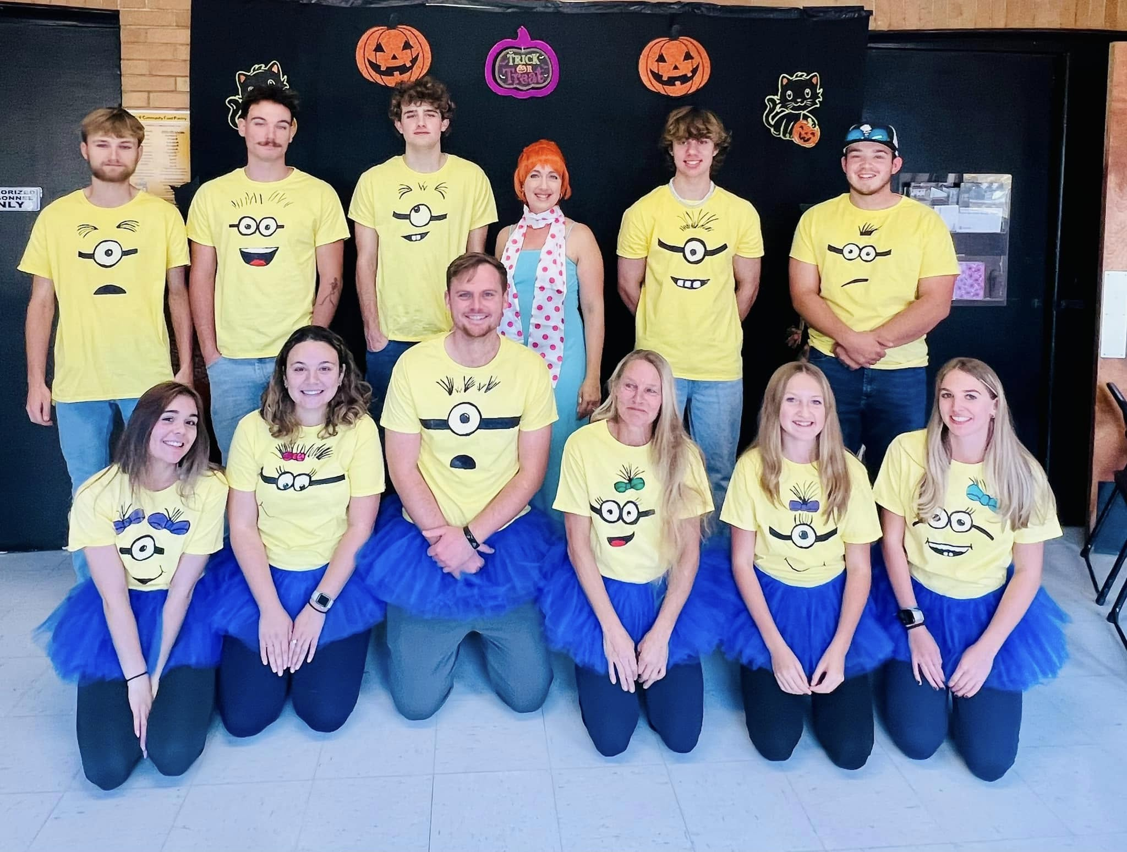

This is not a Mt. Blue RSD sponsored activity, but its information is being distributed through the public schools as community service. All costs

associated with this flyer are paid for by the Farmington Recreation Department.