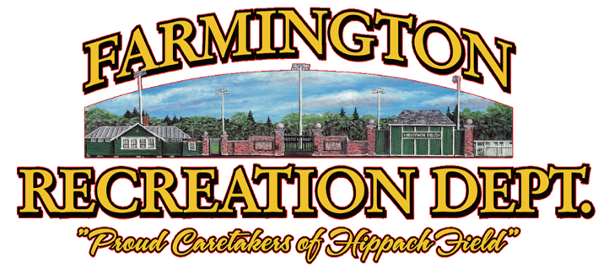

**Registration**

**is FREE**



**Please dress up in bright colors for the BIG SHOW!**

**Age 3-4 -**April 29, May 6, 13, 20, 22 and 29 **Practice 5:30-6pm**

**Age 5 and UP** – April 29, May 6, 13, 20, 22 and 29 **6:00-6:30pm**

**Ages 3 and UP-** May 31, 5:30-6:30 **FULL PERFORMANCE PRACTICE**

**SPRING FLING DANCE PERFORMANCE – June 1, 2024, at 6pm**

Join Dance Directors **Sue Jones** and

**Jennifer Savage** at the Farmington Recreation Department for an

exciting dance experience. This program welcomes all children to explore dance,

let loose and have fun! This program is free! During each practice children will enjoy dancing

to several songs with a focus on at least three songs that they will perform in the BIG SHOW. The directors will display all the moves while helping children gain confidence to perform in front of an audience. The directors will lead your children in the same way the night of the BIG SHOW. So even if they may be nervous, this program is for them! We look forward to working with your children and encouraging them through the art of dance!

**Registration!**

**Register at farmingtonme.myrec.com.**

**Call 207-778-3464 with any questions.**

**TOO SWEET DANCE**