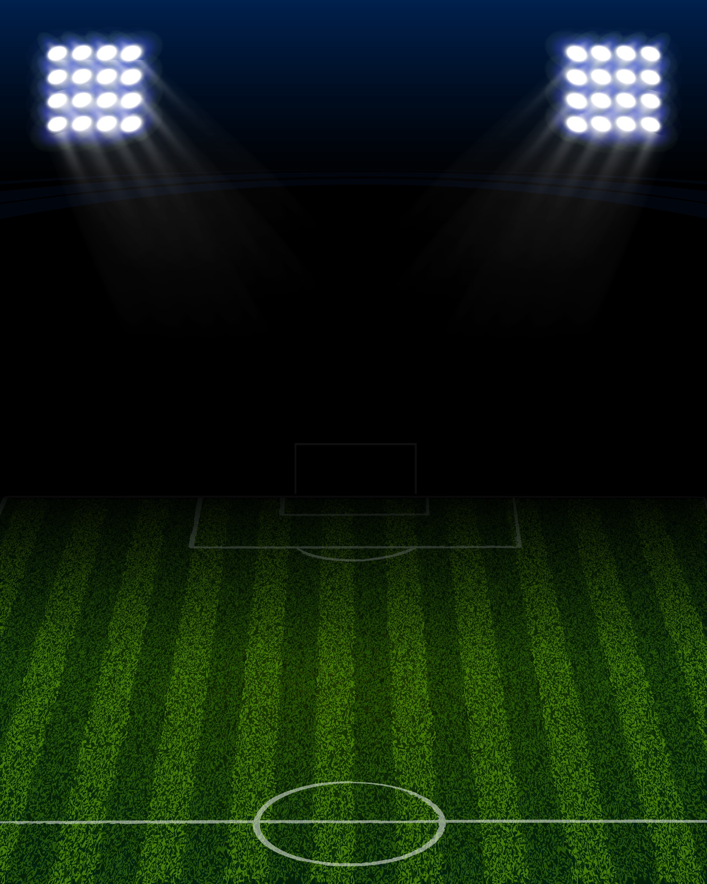

*YOUTH SOCCER LEAGUE*

**The Farmington Youth Soccer League (FYSL) has utilized “Small-Sided Soccer” for over 40 years now. Now widely adopted in the United States, small-sided soccer is a fun and engaging environment for children to learn and grow with fewer players competing on a smaller sized field, allowing all children to be more involved in active play and providing players with more touches and interaction with the ball. Our youth soccer program, developed in collaboration with UMF Soccer Coach, Bob Leib, has provided an excellent platform for players to develop their skills, game awareness, and love for the sport.**



Comprised of two divisions: **Division One (2nd – 3rd Grade) and Division Two (4th – 6th Grade).** All children are assessed during pre-season skills and drills and teams are made each season as evenly as possible to allow a better atmosphere for equal learning and competition. The focus of this league is to teach fundamentals, refine playing skills, improve the fitness levels of our athletes, and educate them in the rules and basic concepts of soccer. **Having fun and building confidence are the primary goals of the program so good sportsmanship is expected of all players and spectators; respect and support should be displayed for every player, coach and referee.**

**Important Dates**

**D1** Skills and Drills: 1pm, Sept. 8th

**D1** First Practice: 5:30-6:45pm, Sept. 10th

**D2** Skills and Drills: 2pm, Sept. 8th

**D2** First Practice: 5:30-6:45pm, Sept. 12th

*Schedule will be handed out at the first practice

**Register online at Farmingtonme.myrec.com**

Registration Deadline: Sept. 5th

Farmington Resident - $40.00

Non-Resident - $50.00

(Prices include jersey fee)

**Games will be played on Sunday afternoons at Hippach Field, and practices will be held weekday evenings at Hippach as well (please see the attached schedule for specific times). The end of the season will be celebrated with a night of “MEDAL MADNESS” where we analyze season scores and rankings to determine best matchups to play under the lights with awards, medals, and music!**

See reverse for more infomation

In the event of inclement weather please check our Facebook page ([www.facebook.com/farmingtonrec](http://www.facebook.com/farmingtonrec)) for notice of any cancellations. **Announcements should be posted one hour before event.**

For more information about this program, call 778-3464 Monday through Friday 9:00 a.m. to 5:00 p.m**.**