**INDOOR Spooktacular**

**October 26, 2024**

**1st, 2nd, and 3rd place trophies for the**

**Winners voted the best decorated!**

**OCTOBER 26, 2024, 4:30 pm to 7:00 p.m.**

**Come join us for a wonderful evening!**

**This year, the Farmington Recreation Department is hoping to bring awareness of free resources available in our area along with other local businesses/organizations, sports teams, and clubs. The event will be inside at the Farmington Community Center with decorated displays for the children and obviously candy! Each child will vote on their favorite as they exit.**

**Remember your vote counts!**

**Registration Required!**

There will be a limited number of registrations taken per 20 minute time block in order to ensure enough candy for all children and help with the safety of parking.

**Registrations open October 4, 2024, ONLINE farmingtonme.myrec.com Call @ 778-3464 with questions.**

**We are located at 127 Middle Street, Farmington, ME**.

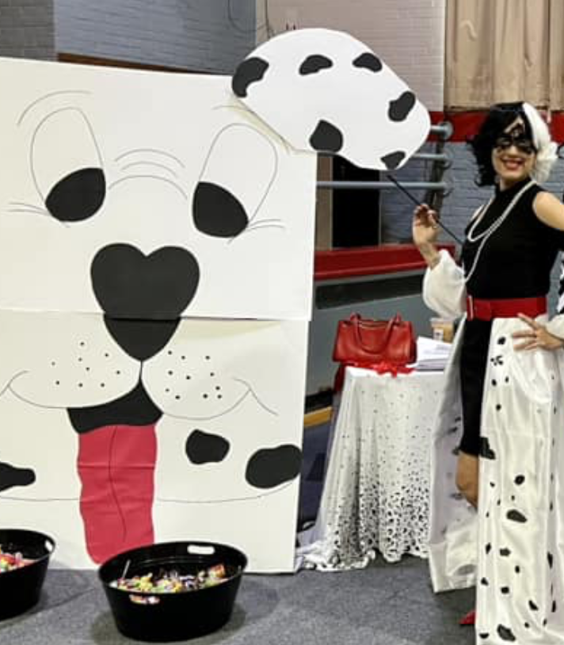

Games and photobooths!

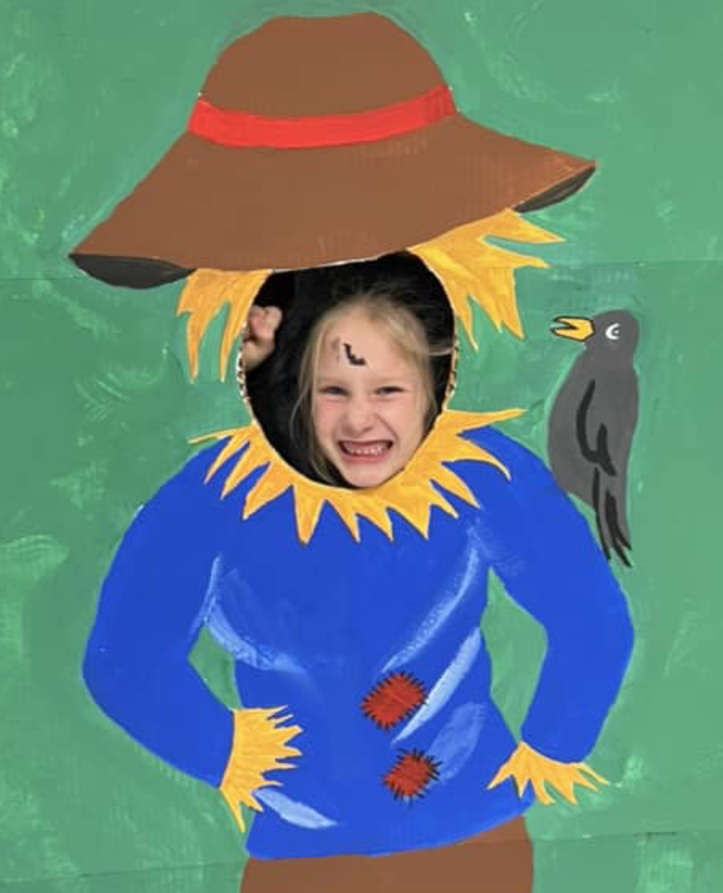



This is not a Mt. Blue RSD sponsored activity, but its information is being distributed through the public schools as community service. All costs

associated with this flyer are paid for by the Farmington Recreation Department.

